E-COMMERCE ORDER MANAGEMENT DATABASE SYSTEM

PERFORM ORDER OPERATIONS

1. Insert Operation
The Insert operation is used to add new records to the database. In this system, a new order is inserted into the Orders table with Order ID, Customer ID, Order Date, Total Amount, and Order Status. A purchased product is also added to the Order_Details table with its Product ID, Quantity, and Price.

2. Update Operation
The Update operation is used to modify existing order records. In this system, the order status is updated to Delivered, and the product quantity is changed from 2 to 3. The total order amount is recalculated by multiplying the product quantity by its price.

3. Delete Operation
The Delete operation is used to remove unwanted records from the database. In this system, a test order with Order ID 5003 and status Cancelled is created and then deleted. The condition ensures that only the specified cancelled order is removed.

4. Display Remaining Orders
The SELECT * FROM Orders; query displays all remaining records in the Orders table. The SELECT * FROM Order_Details; query displays the product details associated with orders. These queries help verify the results of the insert, update, and delete operations.

5. Screenshots
- Figure 1: Insert New Order and Purchased Product
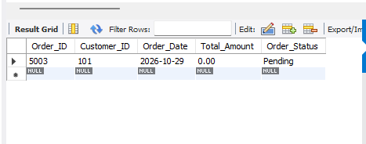
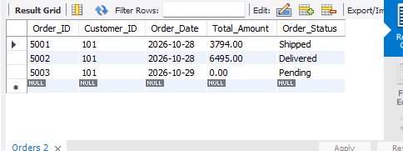
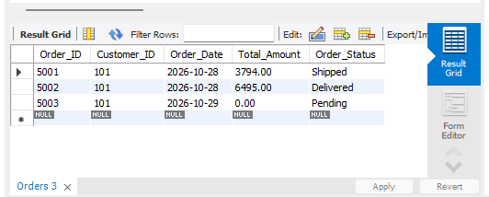
- Figure 2: Update Order Status and Product Quantity
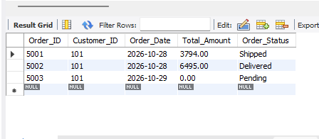

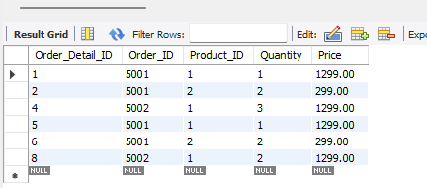
- Figure 3: Recalculate Total Order Amount
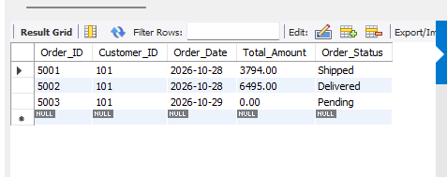
- Figure 4: Delete Cancelled Test Order
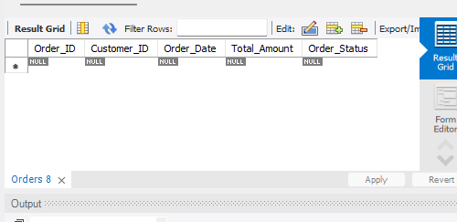
- Figure 5: Display Remaining Orders and Order Details
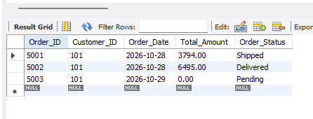
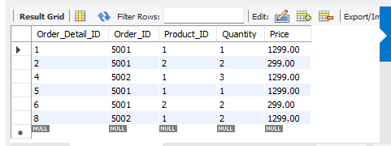

6. Conclusion
The order operations demonstrate how to insert, update, and delete order records using SQL commands. These operations help manage customer orders, purchased products, quantities, prices, and order statuses efficiently while maintaining data consistency in the E-Commerce Order Management Database System.

